Read the question, “What is the relationship between store trading duration and revenue?”
Attempted to familiarise myself with data base, including finding online documentation and diagrams.
https://dataedo.com/download/AdventureWorks.pdf
next I displayed the schema information
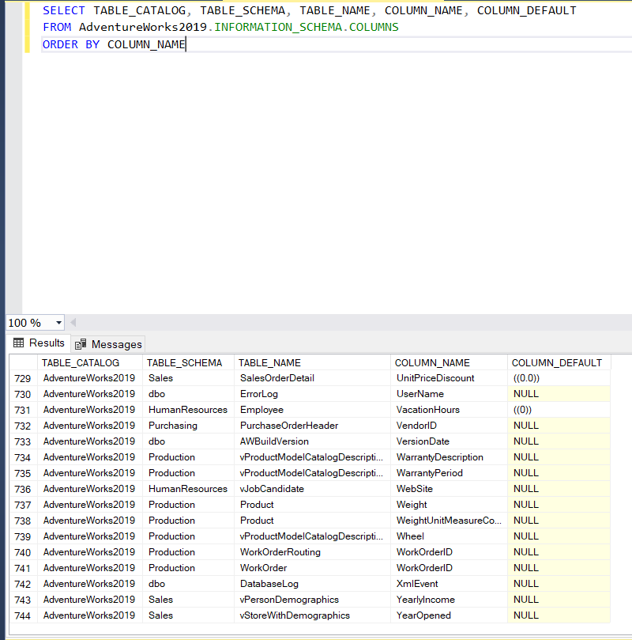
Code to reproduce
SELECT TABLE_CATALOG, TABLE_SCHEMA, TABLE_NAME, COLUMN_NAME, COLUMN_DEFAULT
FROM AdventureWorks2019.INFORMATION_SCHEMA.COLUMNS
ORDER BY COLUMN_NAME

Problem, the ambiguous question. After looking at the data it became apparent that adventure works doesn’t have any stores. The different stores listed are the store that adventure works sells to. Subsequently it became clear that a shops revenue referred to the shops expenses that were attributed to the purchase of adventure works goods/services.
secondly trading duration could refer to either the length of time a shop is open, its opening hours, or how long a shop has been trading for. By searching though the data base I determined that there was no data relating to how long the shops were open for. although I considered several options for estimating opening hours, I concluded that without access to information regarding opening hours in the first place there was no way of knowing how accurate the estimate would be, rendering it essentially useless. the only relevant data I could find in the data base was how long a given shop had been in business.
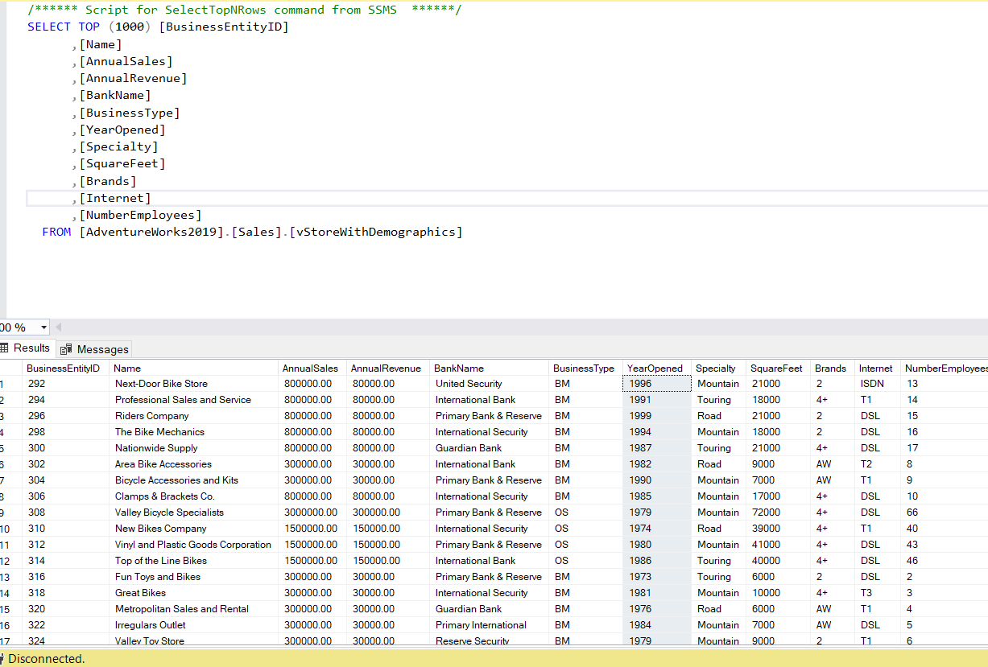
Note the YearOpened Colum

Code to reproduce
SELECT TOP (1000) [BusinessEntityID]
,[Name]
,[AnnualSales]
,[AnnualRevenue]
,[BankName]
,[BusinessType]
,[YearOpened]
,[Specialty]
,[SquareFeet]
,[Brands]
,[Internet]
,[NumberEmployees]
FROM [AdventureWorks2019].[Sales].[vStoreWithDemographics]
I determined the real question to instead be “what is the relationship between the length of time a shop has been in business, and the sales adventure works makes to that shop”.
Armed with the real question I set out to find the relevant information.
Luckily for me the relevant information was all found on a single view
[AdventureWorks2019].[Sales].[vStoreWithDemographics]
I searched for null values, and there were none.
.
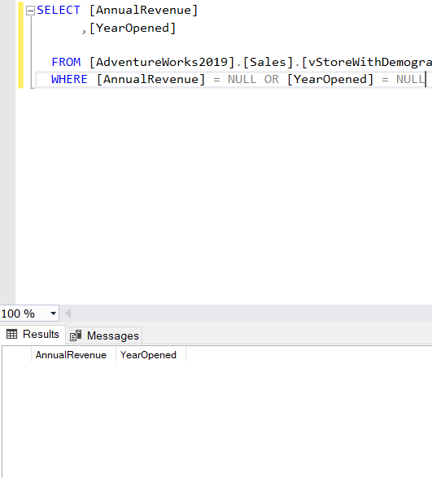
Note no returned rows
Code to reproduce
SELECT [AnnualRevenue]
,[YearOpened]

FROM [AdventureWorks2019].[Sales].[vStoreWithDemographics]
WHERE [AnnualRevenue] = NULL OR [YearOpened] = NULL

Initially I thought that AnnualSales and AnnualRevenue we the same. I used the following code to show only results where AnnualSales and AnnualRevenue were different.
SELECT
[AnnualSales]
,[AnnualRevenue]
FROM [AdventureWorks2019].[Sales].[vStoreWithDemographics]
WHERE AnnualSales != AnnualRevenue
This returned every single result. On closer inspection it appeared that AnnualSales was 10 times AnnualRevenue. To check this I used the following code that divides AnnualSales by 10 then returns fields where AnnualSales and AnnualRevenue were different.
SELECT
[AnnualSales]
,[AnnualRevenue]
FROM [AdventureWorks2019].[Sales].[vStoreWithDemographics]
WHERE ([AnnualSales]/10) != AnnualRevenue
This query returned no rows indicating that AnnualSales was always 10 times AnnualRevenue.
The next step is turning the information in the YearOpened collum into the information we want to see, how long a shop is open for. This can be achieved by the simple expedient of subtracting YearOpened from the current year, 2022. 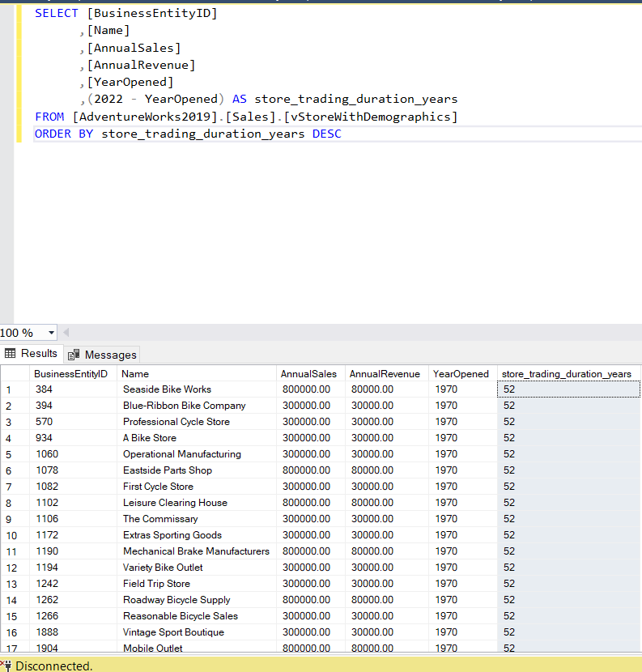
Note store_trading_duration_years colum

Code to reproduce

SELECT [BusinessEntityID]
,[Name]
,[AnnualSales]
,[AnnualRevenue]
,[YearOpened]
,(2022 - YearOpened) AS store_trading_duration_years
FROM [AdventureWorks2019].[Sales].[vStoreWithDemographics]
ORDER BY store_trading_duration_years DESC

After that I grouped stores by number of years that they had been opened and then averaged the revenue of stores that have been open the same number of years.
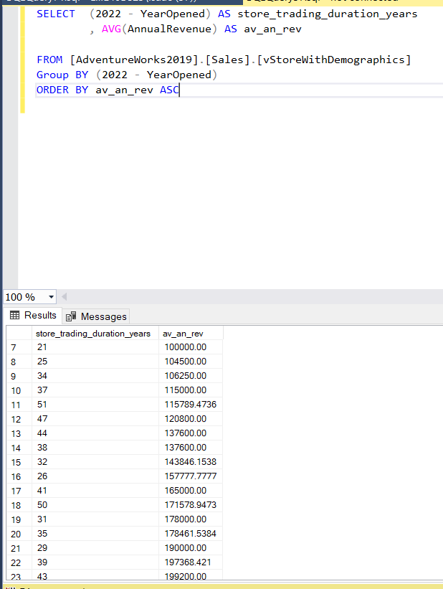

Code to reproduce

SELECT (2022 - YearOpened) AS store_trading_duration_years
, AVG(AnnualRevenue) AS av_an_rev

FROM [AdventureWorks2019].[Sales].[vStoreWithDemographics]
Group BY (2022 - YearOpened)
ORDER BY av_an_rev ASC

Next I export the data to csv. Inorder to preserve the colum headings I select all query results then copy with headers into a new csv file[see attached file, relevent data4].

Next I import relevent data4 into python then generate a summery of the data, coraletion, and graphs using the following code.
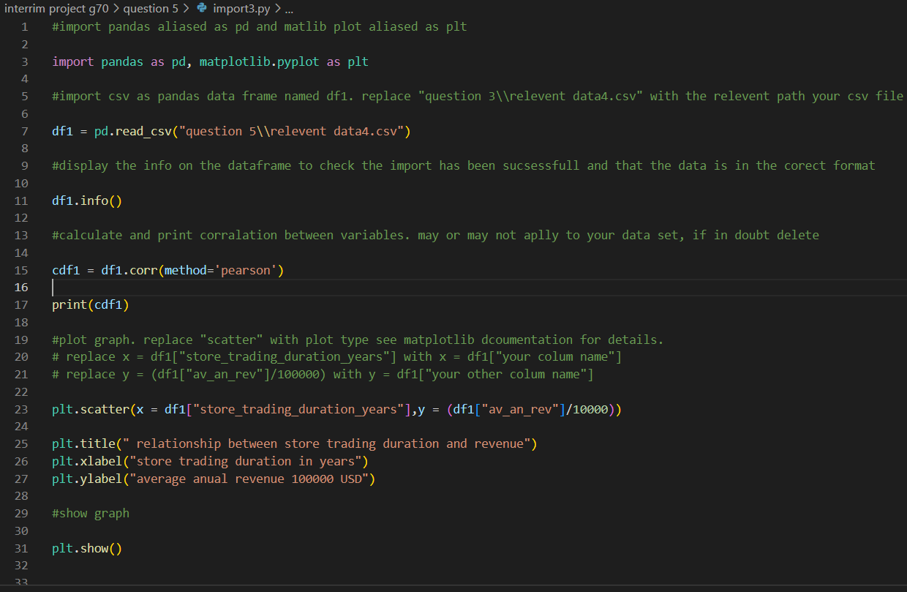
Code to reproduce
#import pandas aliased as pd and matlib plot aliased as plt

import pandas as pd, matplotlib.pyplot as plt

#import csv as pandas data frame named df1. replace "question 3\\relevent data4.csv" with the relevent path your csv file

df1 = pd.read_csv("question 5\\relevent data4.csv")

#display the info on the dataframe to check the import has been sucsessfull and that the data is in the corect format

df1.info()

#calculate and print corralation between variables. may or may not aplly to your data set, if in doubt delete

cdf1 = df1.corr(method='pearson')

print(cdf1)

#plot graph. replace "scatter" with plot type see matplotlib dcoumentation for details.
# replace x = df1["store_trading_duration_years"] with x = df1["your colum name"]
# replace y = (df1["av_an_rev"]/100000) with y = df1["your other colum name"]

plt.scatter(x = df1["store_trading_duration_years"],y = (df1["av_an_rev"]/10000))

plt.title(" relationship between store trading duration and revenue")
plt.xlabel("store trading duration in years")
plt.ylabel("average anual revenue 100000 USD")

#show graph

plt.show()

This generates the following output
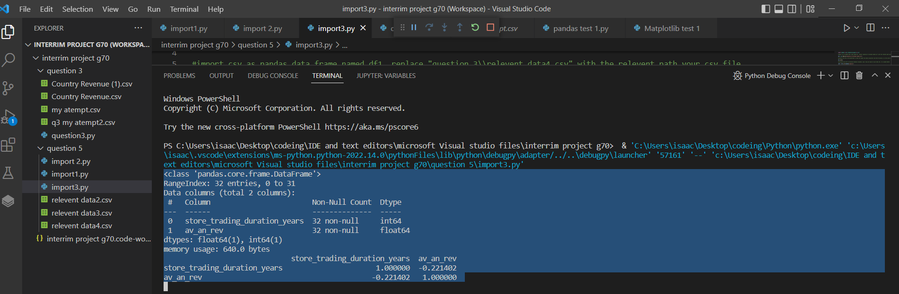

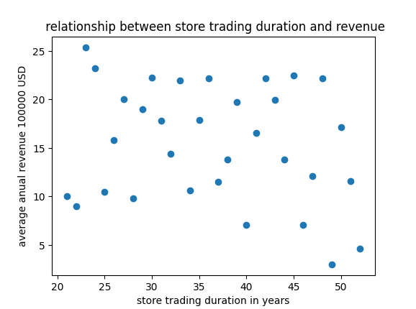
[See attached file, relationship between store years and revenue]

While its is difficult to determine a relationship from looing at the scatter plot, the output of
cdf1 = df1.corr(method='pearson')

print(cdf1)

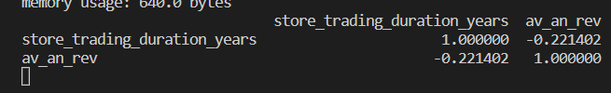
The value of -0.221402 suggests a very week negative correlation

Late in the day I received information stating that it was “not recommended”, whatever that means, to use the revenue figure from.
[AdventureWorks2019].[Sales].[vStoreWithDemographics]
To get the revenue per store without using this view required a complex series of joins and grouping.
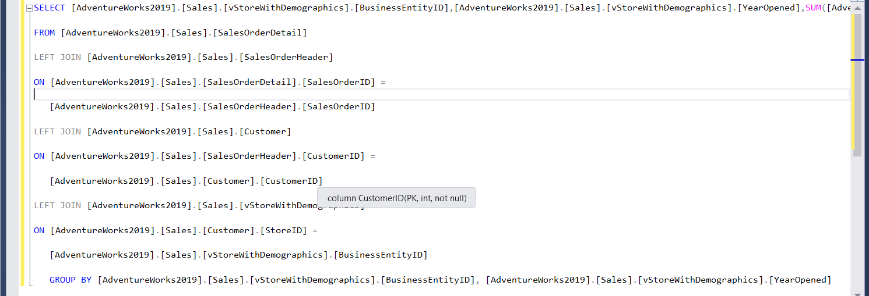
Output
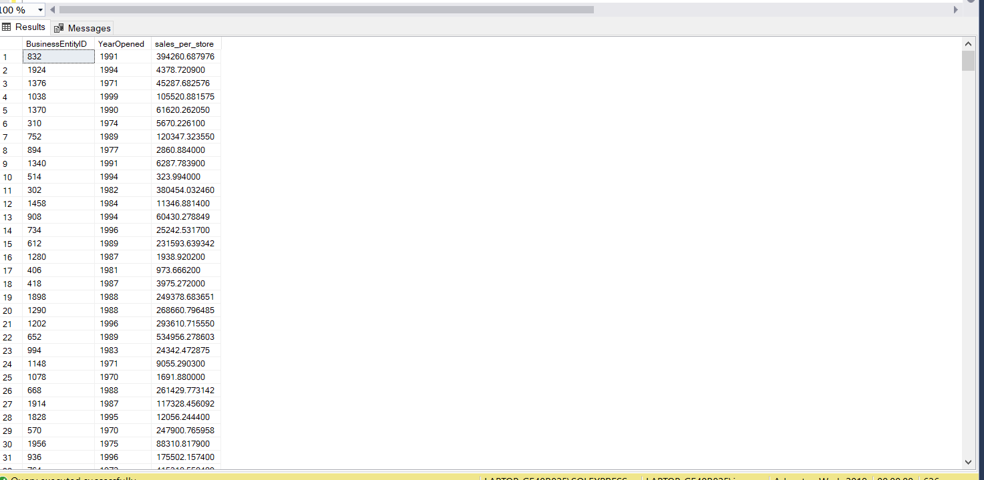

Code to reproduce

SELECT [AdventureWorks2019].[Sales].[vStoreWithDemographics].[BusinessEntityID],[AdventureWorks2019].[Sales].[vStoreWithDemographics].[YearOpened],SUM([AdventureWorks2019].[Sales].[SalesOrderDetail].[LineTotal]) AS sales_per_store

FROM [AdventureWorks2019].[Sales].[SalesOrderDetail]

LEFT JOIN [AdventureWorks2019].[Sales].[SalesOrderHeader]

ON [AdventureWorks2019].[Sales].[SalesOrderDetail].[SalesOrderID] =

[AdventureWorks2019].[Sales].[SalesOrderHeader].[SalesOrderID]

LEFT JOIN [AdventureWorks2019].[Sales].[Customer]

ON [AdventureWorks2019].[Sales].[SalesOrderHeader].[CustomerID] =

[AdventureWorks2019].[Sales].[Customer].[CustomerID]

LEFT JOIN [AdventureWorks2019].[Sales].[vStoreWithDemographics]

ON [AdventureWorks2019].[Sales].[Customer].[StoreID] =

[AdventureWorks2019].[Sales].[vStoreWithDemographics].[BusinessEntityID]

GROUP BY [AdventureWorks2019].[Sales].[vStoreWithDemographics].[BusinessEntityID], [AdventureWorks2019].[Sales].[vStoreWithDemographics].[YearOpened]
Looking over the output I found the following null value. I considered simply excluding it but since it was quite large I decided to investigate its origin.
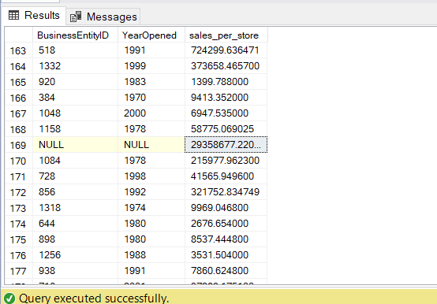
To this end I generated the following query, that groups and sums the line totals after each join to enable me to detect any discrepancy.
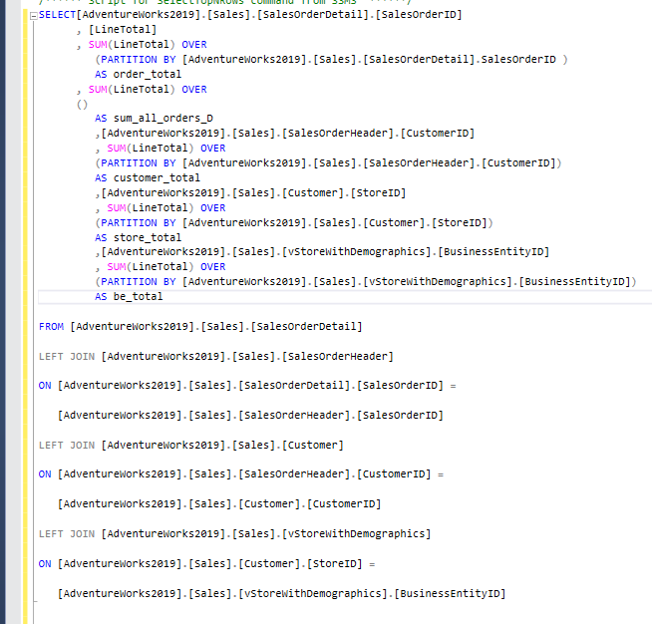

Code to reproduce
SELECT[AdventureWorks2019].[Sales].[SalesOrderDetail].[SalesOrderID]
, [LineTotal]
, SUM(LineTotal) OVER
(PARTITION BY [AdventureWorks2019].[Sales].[SalesOrderDetail].SalesOrderID )
AS order_total
, SUM(LineTotal) OVER
()
AS sum_all_orders_D
,[AdventureWorks2019].[Sales].[SalesOrderHeader].[CustomerID]
, SUM(LineTotal) OVER
(PARTITION BY [AdventureWorks2019].[Sales].[SalesOrderHeader].[CustomerID])
AS customer_total
,[AdventureWorks2019].[Sales].[Customer].[StoreID]
, SUM(LineTotal) OVER
(PARTITION BY [AdventureWorks2019].[Sales].[Customer].[StoreID])
AS store_total
,[AdventureWorks2019].[Sales].[vStoreWithDemographics].[BusinessEntityID]
, SUM(LineTotal) OVER
(PARTITION BY [AdventureWorks2019].[Sales].[vStoreWithDemographics].[BusinessEntityID])
AS be_total

FROM [AdventureWorks2019].[Sales].[SalesOrderDetail]

LEFT JOIN [AdventureWorks2019].[Sales].[SalesOrderHeader]

ON [AdventureWorks2019].[Sales].[SalesOrderDetail].[SalesOrderID] =

[AdventureWorks2019].[Sales].[SalesOrderHeader].[SalesOrderID]

LEFT JOIN [AdventureWorks2019].[Sales].[Customer]

ON [AdventureWorks2019].[Sales].[SalesOrderHeader].[CustomerID] =

[AdventureWorks2019].[Sales].[Customer].[CustomerID]

LEFT JOIN [AdventureWorks2019].[Sales].[vStoreWithDemographics]

ON [AdventureWorks2019].[Sales].[Customer].[StoreID] =

[AdventureWorks2019].[Sales].[vStoreWithDemographics].[BusinessEntityID]

Output
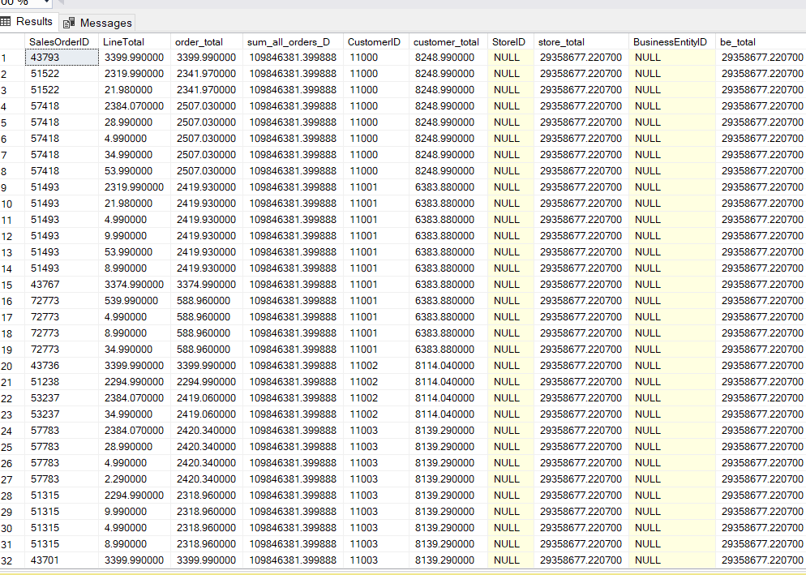
From this output it is clea that the issue was with grouping by [AdventureWorks2019].[Sales].[Customer].[StoreID].
This led me to a closer investigation of [AdventureWorks2019].[Sales].[Customer] wich revealaled that customers were either given a store id or a person id. Since person ids don’t link to individual premises, they presumably represent individual or one of customers as opposed to wholesalers, it is imposible to include them in this analysis and once removed can be ignored.
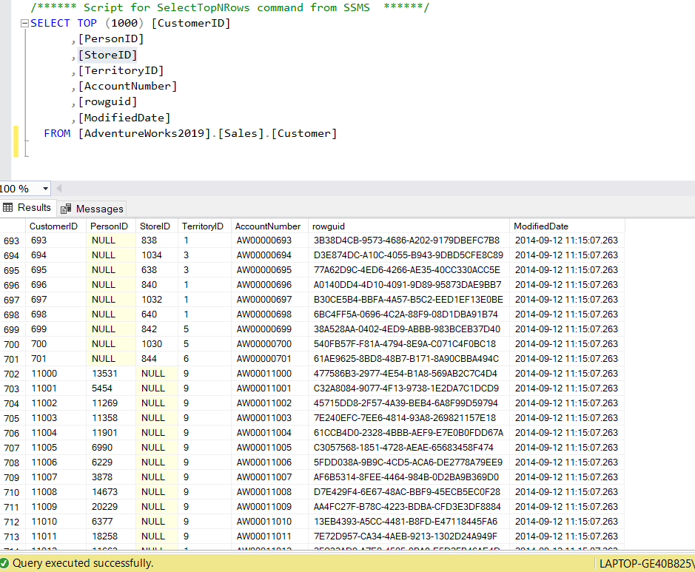

Returning to my earlier efforts to answer the question, I turned this query into a view in order to preform a second round of filtering and grouping on it.
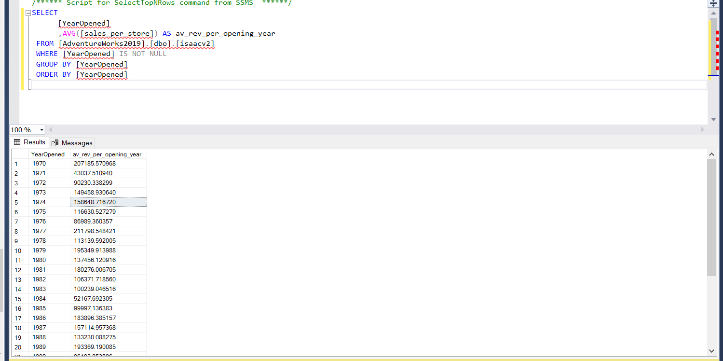

Code to reproduce
SELECT
[YearOpened]
,AVG([sales_per_store]) AS av_rev_per_opening_year
FROM [AdventureWorks2019].[dbo].[isaacv2]
WHERE [YearOpened] IS NOT NULL
GROUP BY [YearOpened]
ORDER BY [YearOpened]

I saved the output as a csv[see attached file v2datab]

Once again I import v2datab into python then generate a summery of the data, coraletion, and graphs using the following code.

#import pandas aliased as pd and matlib plot aliased as plt

import pandas as pd, matplotlib.pyplot as plt

#import csv as pandas data frame named df1. replace "question 3\\relevent data4.csv" with the relevent path your csv file

df1 = pd.read_csv("question 5\\v2datab.csv")

#display the info on the dataframe to check the import has been sucsessfull and that the data is in the corect format

df1.info()

#calculate and print corralation between variables. may or may not aplly to your data set, if in doubt delete

cdf1 = df1.corr(method='pearson')

print(cdf1)

#plot graph. replace "scatter" with plot type see matplotlib dcoumentation for details.
# replace x = df1["store_trading_duration_years"] with x = df1["your colum name"]
# replace y = (df1["av_an_rev"]/100000) with y = df1["your other colum name"]

plt.scatter(x = (2022 - df1["YearOpened"]),y = df1["av_rev_per_opening_year"])

plt.title(" relationship between store trading duration and revenue")
plt.xlabel("store trading duration in years")
plt.ylabel("av_rev_per_opening_year")

#show graph

plt.show()

this generates the following output
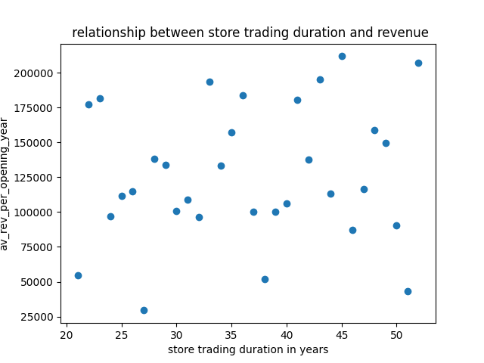

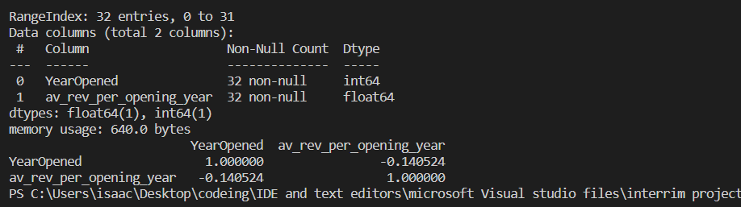
its is stll difficult to determine a relationship from looking at the scatter plot, but the coralation figure quantifys the relationship.

The value of -0.140524 suggests a very week negative correlation

